When you are using a device, what must you understand?

Any device that is used on campus is done **“at your own risk.”** GISD and JTC will not be responsible for any lost, stolen or damaged devices.

Although it is a personal device, any use deemed inappropriate will follow the GISD Acceptable Use Policy and the GISD Code of Conduct.

BYOD is a student privilege that may revoked at any time.

JTC will not provide technical support on any personal device brought to school.

What devices are acceptable?

The following devices are acceptable under the BYOD policy.

* Smartphones (iPhone, Android, Blackberry, etc…)
* iPods/MP3 players with internet access
* iPads/Tablets
* Laptops/Netbooks

WHERE in the building and WHEN can you use your device?

They may be used **in the cafeteria and gyms in the morning before school starts** as long as it is not audible to other people.

**From 8:50-3:50** **student MAY NOT access devices** except for the following reason:

They may be used in the classroom, but you must have an **educational purpose** and **your teacher’s permission**.

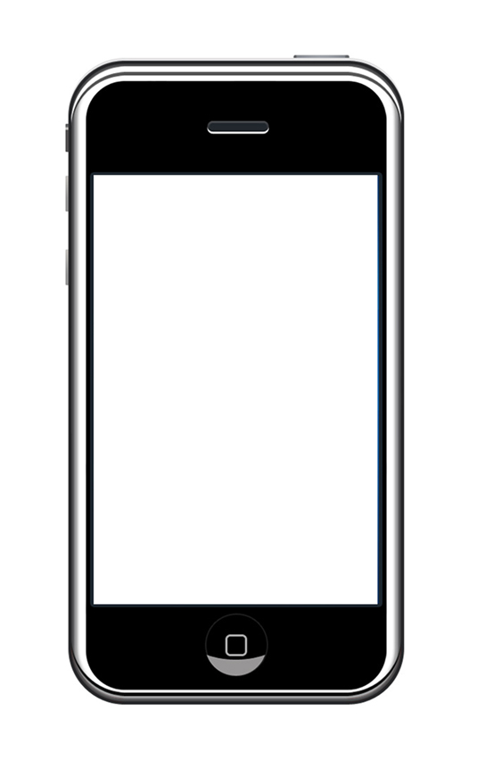

**BYOD**

**Jackson Technology Center**

**“Bring Your Own Device”**

How do you get access?

All students **must** login using their NPIN on the GISDwifi network. (Using your own data plan is not acceptable at school.)