Lakeview Centennial Seniors

COLLEGE APPLICATION CHECKLIST
Adding Colleges To Naviance Student
student.naviance.com/lakeviewchs UN: S + ID # Password: NPIN
- Sign into Naviance Student and click on Colleges tab at the top right, then click on the Colleges I’m Applying to. Next, click the pink plus sign to add a college you are applying to.
- Choose your App Type (Regular Decision, Early Decision, etc.), how you will submit your application (common App or Directly to Institution) & check the box if you have submitted your application to the college.

Adding Colleges To Naviance Student with Common Application
- Create a Common App account on the Common App Online
- Sign the Common App FERPA Waiver and add your high school information on the Common App Online
- Click on Colleges I’m Applying to. Click the button to match your Common App account to Naviance Student. Your colleges that you added to the Common App, will now show up under the Colleges I’m Applying to list in Naviance Student. * You must inform your Counselor if you are using a common application.
Requesting Transcripts
- Click
- Click box next to each college or university you have added & click
YOU WILL NOT BE ABLE TO REQUEST A TRANSCRIPT UNTIL THE STUDENT RELEASE AUTHORIZATION FORM IS COMPLETED & RETURNED TO COUNSELING OFFICE
Requesting Teacher Recommendations
Speak with the teacher in person to request a letter of recommendation and give them at least three weeks to complete the recommendation. After teacher has accepted, it is common courtesy to give the teacher a thank you note.

- Log into Naviance Student, and on the Colleges tab, click Letters of Recommendation.
- Click Add Request to submit a new request to a teacher.
- Select a teacher from the drop-down list.
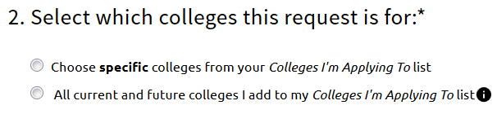
- Choose whether you want this teacher to write a unique letter of recommendation to specific colleges, or a general letter of recommendation to send to all colleges you added to your colleges I’m applying to list.

- Include any specific information about your request (if this is your first-choice school, any specific program or major you are applying for, etc.), and then Submit the request.
- To track your letter of recommendation requests, click on the status under the Status column (requested, submitted, etc.) to view the date and time your school sent the letter to the college.

