2016 GUIDE to Using NAVIANCE
Go to www.garlandisd.net
Click on Departments & Programs

Click on Guidance & Counseling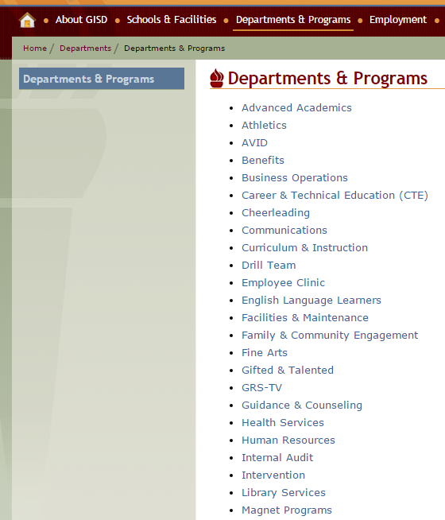

Click on Naviance on the left side of the page.
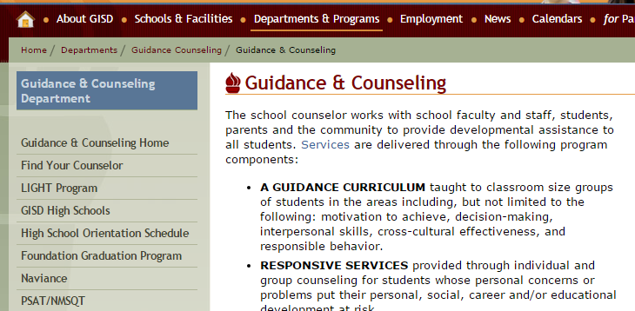

Select Jackson in the drop down menu. Click GO.
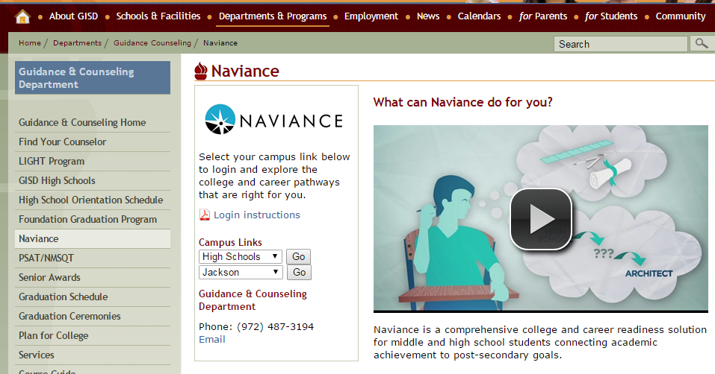

Type in the username and password which has been provided to you.
Click Log in.
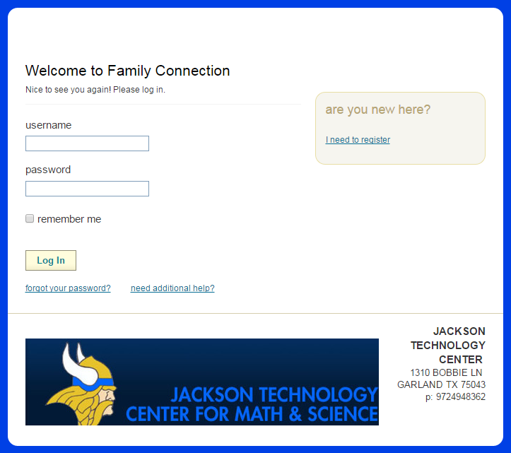

This is what your screen will look like once you are logged in. Click on courses at the top.
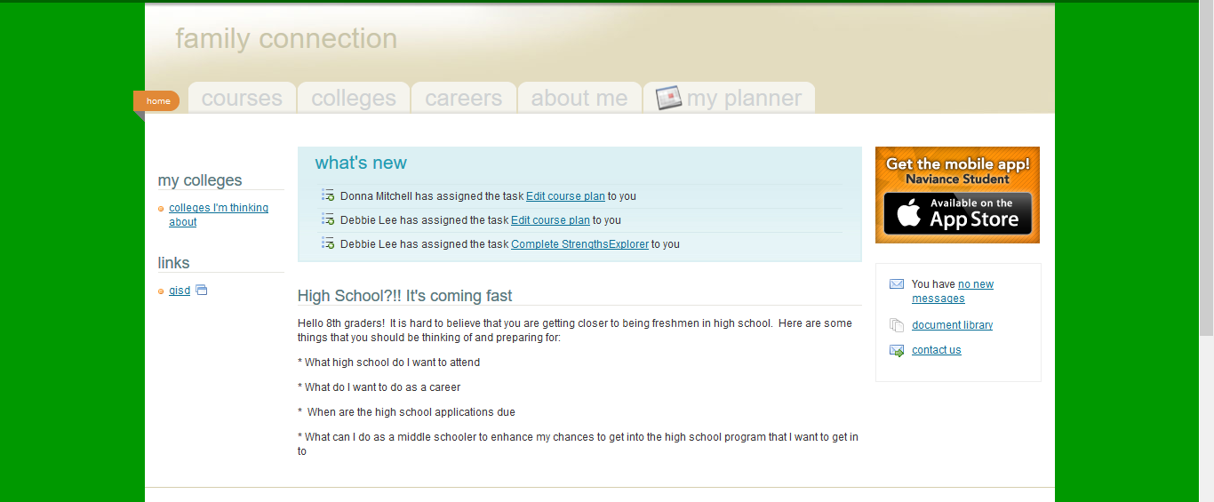

Click on manage my course plans.
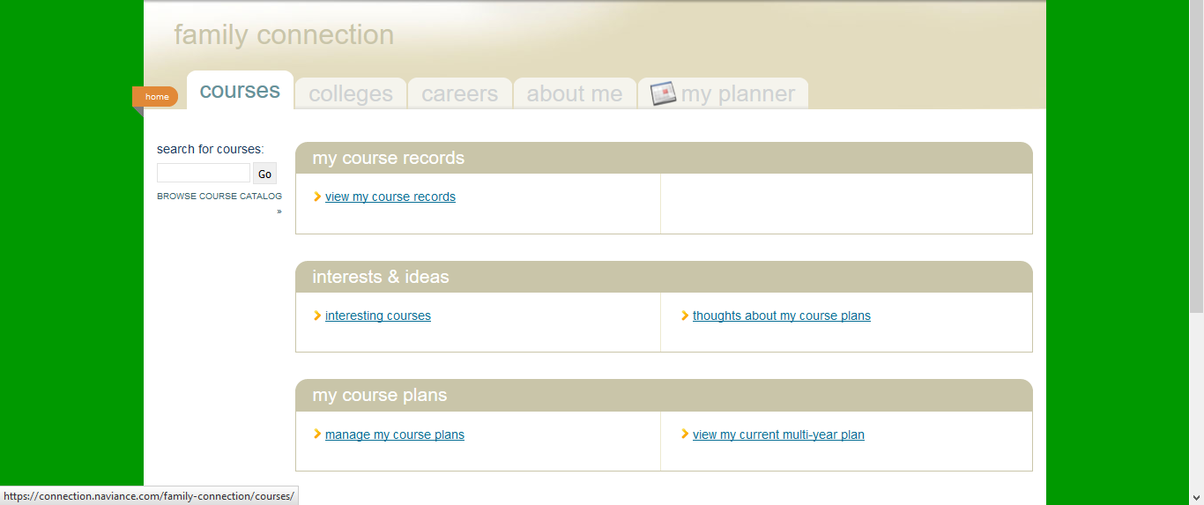

Click add a new plan, High School that you are going to and then click create new draft plan.
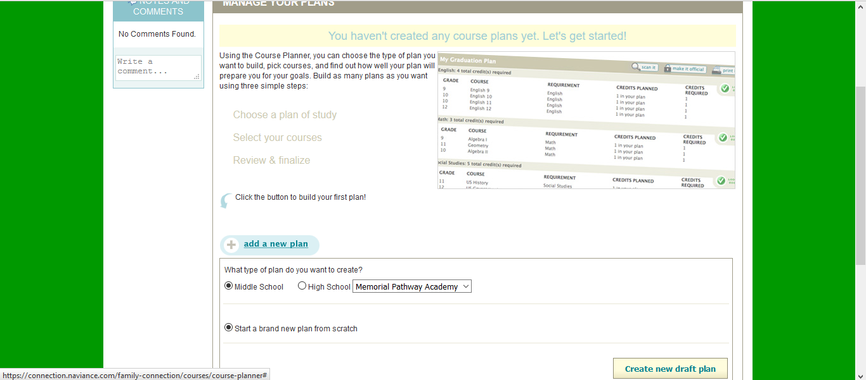

Now you must select your endorsement. Then click on choose this one.
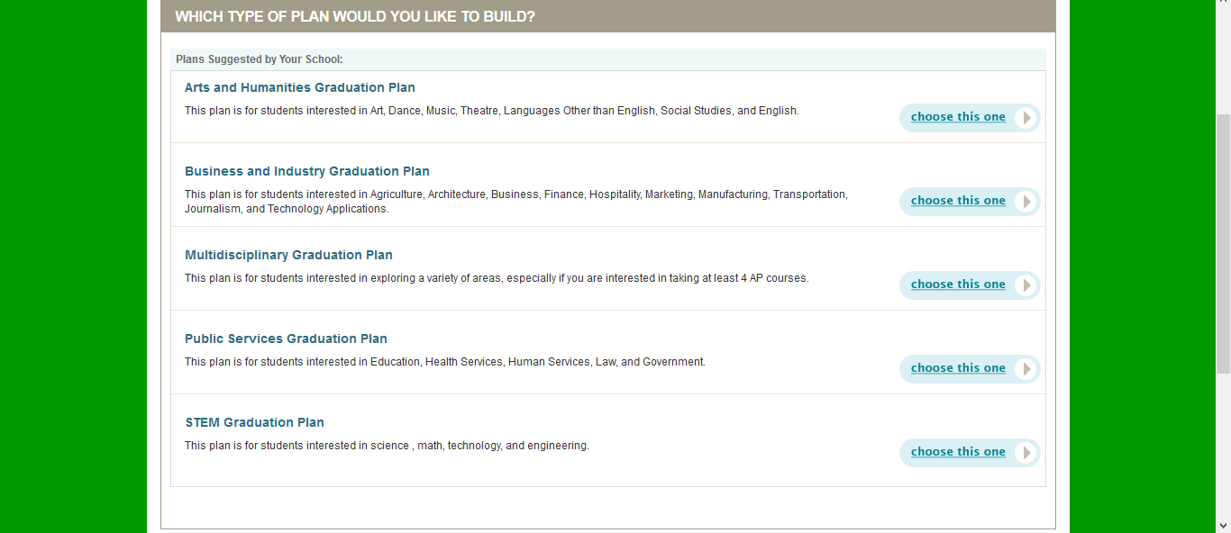

This is what your screen looks like when you are ready to make selections.
This is where you will be selecting your courses.
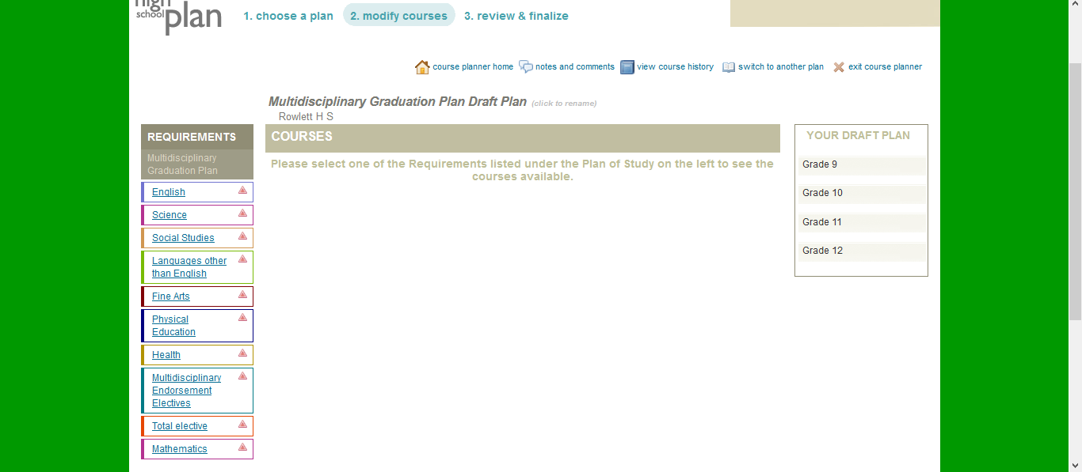

Click on the English link of the left and start to enter your English class from 9th to 12th grade.
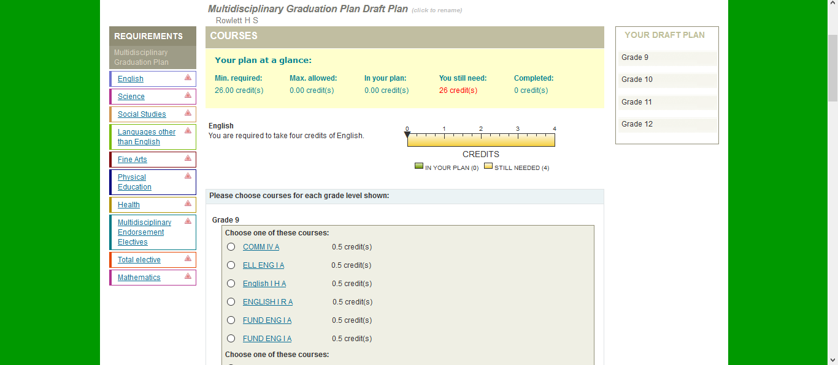

Make sure that you pick the “A” and “B” side of each course.
A & B indicate 1st and 2nd semesters.
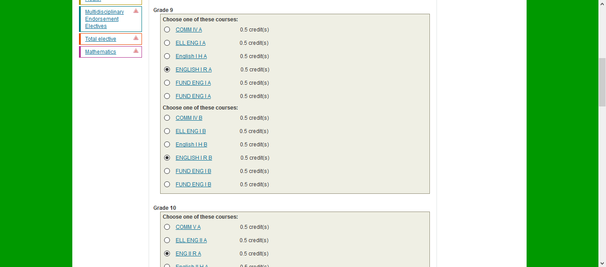

Once all years are entered then click on Add selected courses to your draft plan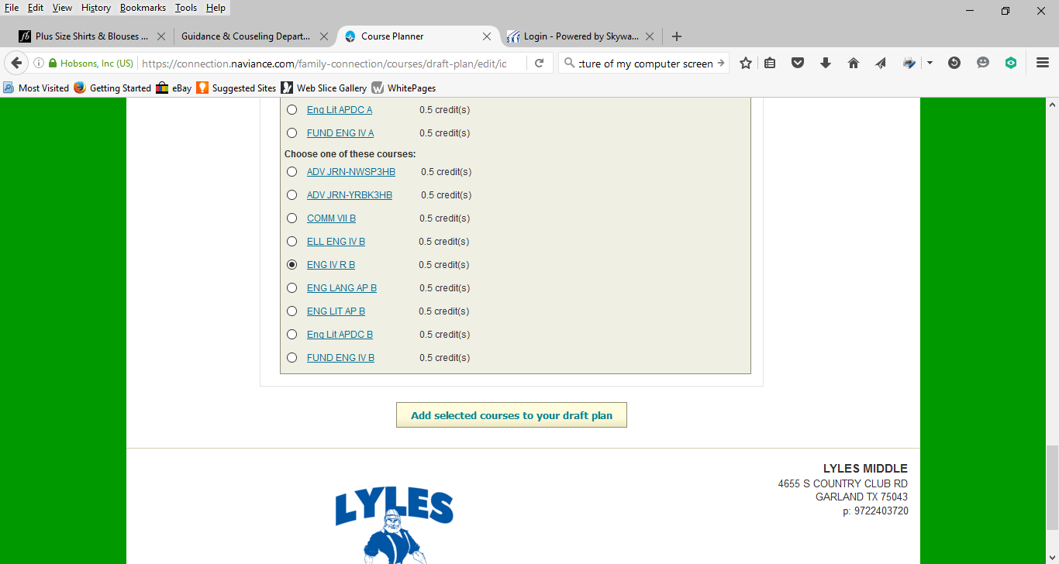

This screen will pop up. Click Okay!
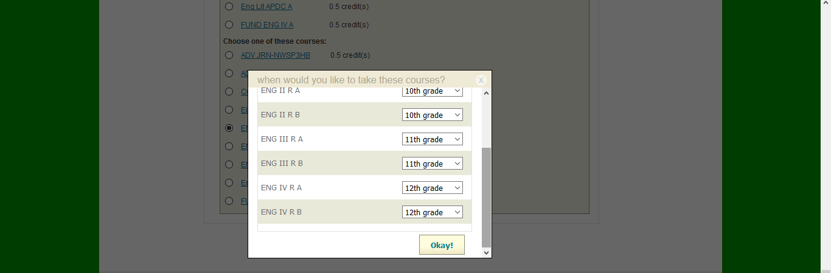

This what your screen will look like. Click on the next link for Science.
Continue to fill in the courses. Remember to pick the “A” and “B” side for each course.
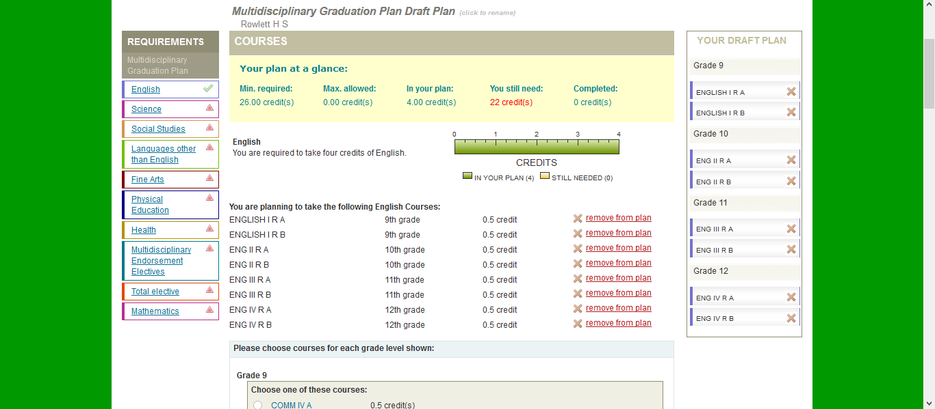

Congratulations on finishing your Course Selections for NEXT year!

